29th Nov 2016 926/16
Dan Eilat - renovated rooms
Dear Agent,
It is our pleasure to inform you that we have fully renovated part of the rooms and created new room categories at the Dan Eilat Hotel.
We have updated our BAR rates and all new room types are bookable on the system.

New Eilat room- Fully renovated modern design rooms with Private balcony. 29 Sq. m / Max 3 persons, floors 3-5.
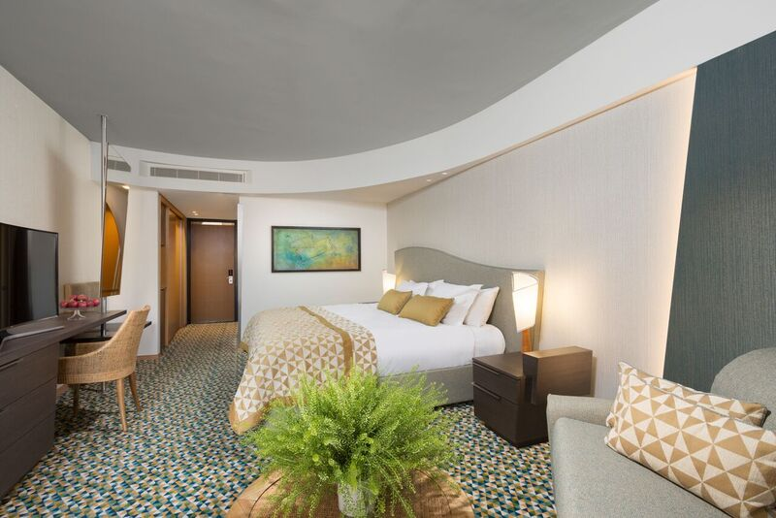

New Superior room-Fully renovated modern design rooms facing the Pool & Sea with private balcony. 34 Sq. m / Max 3 persons, Floors 5-10.

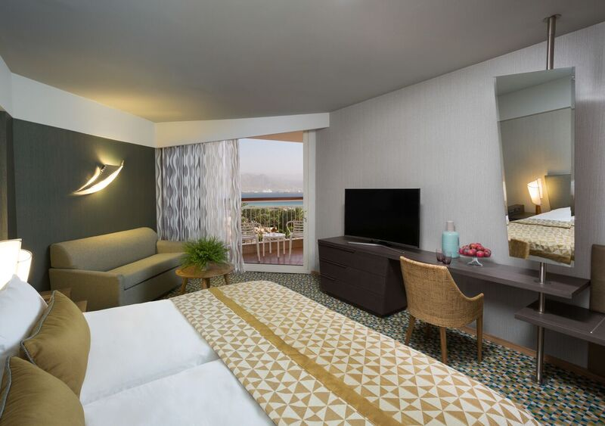

New Deluxe room-Fully renovated, very spacious rooms, modern design overlooking the
Pool & Sea with private balcony. 37 Sq. m / Max 3 persons, Floors 3-10.

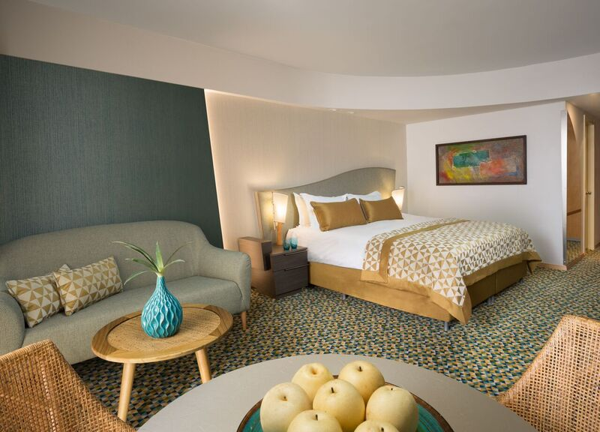

New Executive room- Fully renovated, very spacious rooms, modern design overlooking the
Pool & Sea with Private balcony. 37 Sq. m / Max 3 persons, Floors 11-13, free access to Executive Lounge (from age 18).

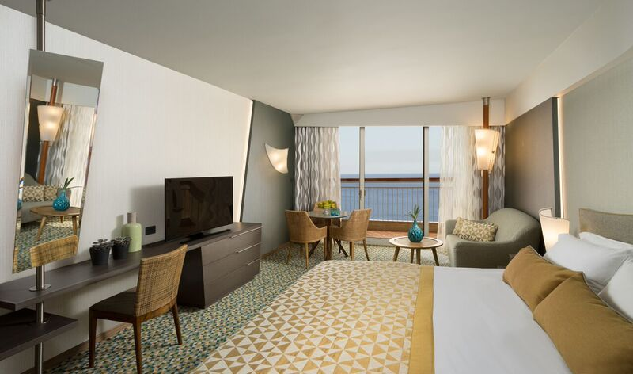

We look forward to welcoming your guests.

Best wishes,

Sagit Hanoch
Sales Operation Manager
Dan Hotels

cc: Hotel GM & Sales
Call Dan
R. Baeri, I. Zoref, Y. Bogen, Moscow office, NY office

